January

Activity Pack 1





Dear Friends,

Wishing you the happiest of New Years as we embark on the journey into 2024! May this year bring an abundance of light, hope, and joy into our lives, and may you always be aware that you are never far from our thoughts.

As our evenings gradually grow brighter with each passing day, so does the promise of a year in which we aspire to be more present in each other's lives. Remember, the ASI is just a phone call away whenever you need us. Our helpline number, 1800 341 341, connects you with our volunteers ready to listen and support you.

We hope that January unfolds for all our readers a prosperous, exciting, and healthy new year. Your support has been invaluable, and we extend our heartfelt thanks. Here's to a successful and fulfilling new year ahead!



“New month, new intentions, new goals, new love, new light, and new beginnings.”  
— April Mae Monterrosa

**Useful Resources:**

**Useful Resources:**

2. The ASI now also has a new online Virtual Dementia Hub where you can go for a full range of activities – you can even listen to some wonderful poetry and songs especially. Just go to [www.virtualdementiahub.ie](http://www.virtualdementiahub.ie)

3. We are hosting a number of Virtual Cafes. They are a place to come together, share a cuppa and listen to our amazing guest speakers. For information on how to attend visit: <https://alzheimer.ie/service/alzheimer-cafe/>

4. The ASI also have a huge library of factsheets and resources available on: <https://alzheimer.ie/get-support/resources-and-factsheets/>

5. For musical videos and resources Music For Dementia are a wonderful resource: <https://musicfordementia.org.uk/>

6. The Irish Museum of Modern Art (IMMA) have a huge collection available to view online at: <https://imma.ie/collection/>

7. Emergency Response Numbers: 999 or 112 9. HSE 24/7 Your Mental Health Information Helpline: 1800 111 888

8. Our Free Helpline and Dementia Nurse Support Line are available at: Phone: **1800 341 341** and Email: [**helpline@alzheimer.ie**](mailto:helpline@alzheimer.ie)

9. The Irish Museum of Modern Art is running a series called “Talking Art Online” where they take a close look at selected artworks from the IMMA Collection and discuss IMMA exhibitions with their Visitor Engagement Team from the comfort of your living room. To book and for more information, please email talkingart@imma.ie or phone 01 612 9955



**Table of Contents**

|  |  |
| --- | --- |
| *Activity* | *Pages* |
| General Knowledge Quiz | **5-9** |
| Good Night and Good Morning By Richard Monckton Milnes, Lord Houghton | **10-11** |
| Create the Soundtrack of Your Life | **13** |
| US Presidents and their Wives | **14-15** |
| Pictures to Colour | **16-19** |
| New Years WordSearch | **20** |
| January WordSearch | **21** |
| Help the Birds Find Their Nest | **22-23** |
| Funny Limericks and Ryhmes | **24** |
| Buttercups and Daisies by Mary Howett | **25-26** |
| iSpy | **27** |
| Get to Know me Better | **28** |
| iSpy | **29** |
| The King of The Birds Folktale | **30** |
| Butterfly Meditation | **31-32** |

**General Knowledge Quiz:**

1. Who was the first man on the moon?
2. What was the name of Sri Lanka before 1972?
3. What happened on the 6th of June 1944?
4. Who was the first woman to become Prime Minister of the UK?
5. What does the acronym EU stand for?
6. Which author created the character of Hercule Poirot?
7. Who was the first President of the US?
8. What is the currency in use in Australia?
9. What type of beverage is Jameson?
10. Which author wrote To Kill a Mockingbird?

**Round 1: Answers**

1. Who was the first man on the moon? **Neil Armstrong**
2. What was the name of Sri Lanka before 1972? **Ceylon**
3. What happened on the 6th of June 1944? **D-day, Normandy Landings**
4. Who was the first woman to become Prime Minister of the UK? **Margaret Thatchet**
5. What does the acronym [**EU**](https://www.quiztriviagames.com/european-union-quiz/) stand for? **European Union**
6. Which author created the character of Hercule Poirot? **Agatha Christie**
7. Who was the first President of the US? **George Washington**
8. What is the currency in use in Australia? **Australian Dollar**
9. What type of beverage is Jameson? **Whiskey**
10. Which author wrote To Kill a Mockingbird? **Harper Lee**
11. Joe DiMaggio was the second husband of which famous actress?
    1. Marilyn Monroe
    2. Betty White
    3. Grace Kelly
    4. Doris Day
12. Which US President was involved in the Watergate scandal in the 70s?
    1. Jimmy Garter
    2. Harry S. Truman
    3. Richard Nixon
    4. Dwight D. Eisenhower
13. Which one of the following Disney movies came first?
    1. Beauty and the Beast
    2. Aladdin
    3. Hercule
    4. Cinderella
14. What is the best medal that can be won at the Olympics?
    1. Diamond
    2. Gold
    3. Silver
    4. Bronze
15. Which instrument is Eric Clapton famous for playing?
    1. Piano
    2. Harmonica
    3. Guitar
    4. Drums

**Round 2: Answers**

1. Joe DiMaggio was the second husband of which famous actress? **Marilyn Monroe**
2. Which [**US President**](https://www.quiztriviagames.com/us-presidents-quiz/) was involved in the Watergate scandal in the 70s? **Richard Nixon**
3. Which one of the following [**Disney**](https://www.quiztriviagames.com/easy-disney-quiz/) movies came first? **Cinderella**
4. What is the best medal that can be won at the Olympics? **Gold**
5. Which instrument is Eric Clapton famous for playing? [**Guitar**](https://www.quiztriviagames.com/guitar-quiz/)

**Good Night and Good Morning**

**By Richard Monckton Milnes, Lord Houghton**

A fair little girl sat under a tree,

Sewing as long as her eyes could see;

Then smoothed her work, and folded it right,

And said, "Dear work, good night! good night!"

Such a number of rooks came over her head,

Crying, "Caw! Caw!" on their way to bed;

She said, as she watched their curious flight,

"Little black things, good night! good night!"

The horses neighed, and the oxen lowed,

The sheep's "Bleat! bleat!" came over the road;

All seeming to say, with a quiet delight,

"Good little girl, good night! good night!"

She did not say to the sun, "Good night!"

Though she saw him there like a ball of light,

For she knew he had earth's time to keep

All over the world, and never could sleep.

The tall pink foxglove bowed his head,

The violets curtsied and went to bed;

And good little Lucy tied up her hair,

And said on her knees her favourite prayer.

And while on her pillow she softly lay,

She knew nothing more till again it was day;

And all things said to the beautiful sun,

"Good morning! good morning! our work is begun!

**US Presidents and the First Ladies**

**Draw a line from the president’s name to the name of his wife**

George Washington Jacqueline

George H.W. Bush Hilary

Donald J Trump Barbara

Harry S Truman Abigail

John F Kennedy Martha

John Adams Melania

Bill Clinton Elizabeth “Bess”

Franklin D Roosevelt Alice

Gerard R Ford Eleanor

Ronald R Regan Betty

Barack Obama Michelle

Theodore Roosevelt Nancy

Jimmy Carter Rosalynn

***Answers US Presidents and the First Ladies:***

George Washington ---- Martha

George H.W. Bush ---- Barbara

Donald J Trump ---- Melania

Harry S Truman ---- Elizabeth “Bess”

John F Kennedy ---- Jacqueline

John Adams ---- Abigail

Bill Clinton ---- Hilary

Franklin D Roosevelt ---- Eleanor

Gerard R Ford ---- Betty

Ronald R Regan ---- Nancy

Barack Obama ---- Michelle

Theodore Roosevelt ---- Alice

Jimmy Carter ---- Rosalynn

**Pictures to Colour**





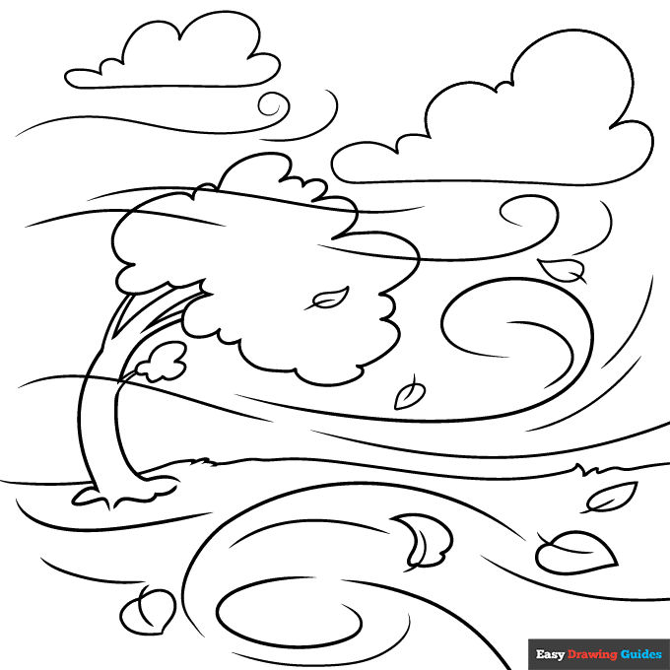

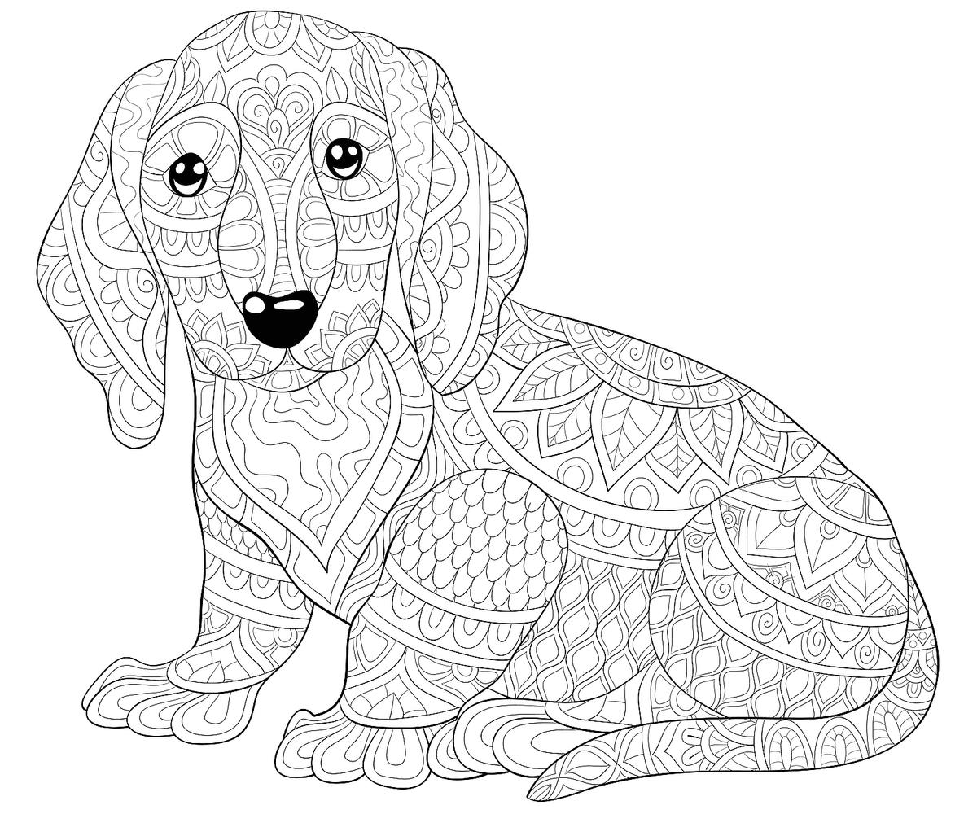



**January Wordsearch**

|  |  |  |  |  |  |  |  |  |  |  |  |  |  |  |  |  |  |  |  |  |  |  |  |  |  |  |  |  |  |  |  |  |  |  |  |  |  |  |  |  |  |  |  |  |  |  |  |  |  |  |  |  |  |  |  |  |  |  |  |  |  |  |  |  |  |  |  |  |  |  |  |  |  |  |  |  |  |  |  |  |  |  |  |  |  |  |  |  |  |  |  |  |  |  |  |  |  |  |  |  |  |  |  |  |  |  |  |  |  |  |  |  |  |  |  |  |  |  |  |  |  |  |  |  |  |  |  |  |  |  |  |  |  |  |  |  |  |  |  |  |  |  |  |  |  |  |  |  |  |  |  |  |  |  |  |  |  |  |  |  |  |  |  |  |  |  |  |  |  |  |  |  |  |  |  |  |  |  |  |  |  |  |  |  |  |  |  |  |  |  |  |  |  |  |  |  |  |  |  |  |  |  |  |  |  |  |  |  |  |  |  |  |  |  |  |  |  |  |  |  |  |  |  |  |  |  |  |  |  |  |  |  |  |  |  |  |  |  |  |  |  |  |  |
| --- | --- | --- | --- | --- | --- | --- | --- | --- | --- | --- | --- | --- | --- | --- | --- | --- | --- | --- | --- | --- | --- | --- | --- | --- | --- | --- | --- | --- | --- | --- | --- | --- | --- | --- | --- | --- | --- | --- | --- | --- | --- | --- | --- | --- | --- | --- | --- | --- | --- | --- | --- | --- | --- | --- | --- | --- | --- | --- | --- | --- | --- | --- | --- | --- | --- | --- | --- | --- | --- | --- | --- | --- | --- | --- | --- | --- | --- | --- | --- | --- | --- | --- | --- | --- | --- | --- | --- | --- | --- | --- | --- | --- | --- | --- | --- | --- | --- | --- | --- | --- | --- | --- | --- | --- | --- | --- | --- | --- | --- | --- | --- | --- | --- | --- | --- | --- | --- | --- | --- | --- | --- | --- | --- | --- | --- | --- | --- | --- | --- | --- | --- | --- | --- | --- | --- | --- | --- | --- | --- | --- | --- | --- | --- | --- | --- | --- | --- | --- | --- | --- | --- | --- | --- | --- | --- | --- | --- | --- | --- | --- | --- | --- | --- | --- | --- | --- | --- | --- | --- | --- | --- | --- | --- | --- | --- | --- | --- | --- | --- | --- | --- | --- | --- | --- | --- | --- | --- | --- | --- | --- | --- | --- | --- | --- | --- | --- | --- | --- | --- | --- | --- | --- | --- | --- | --- | --- | --- | --- | --- | --- | --- | --- | --- | --- | --- | --- | --- | --- | --- | --- | --- | --- | --- | --- | --- | --- | --- | --- | --- | --- | --- | --- | --- | --- | --- | --- | --- | --- | --- | --- | --- | --- | --- |
| |  |  |  |  |  |  |  |  |  |  |  |  |  |  |  |  |  |  |  |  |  |  |  |  |  |  |  |  |  |  |  |  |  |  |  |  |  |  |  |  |  |  |  |  |  |  |  |  |  |  |  |  |  |  |  |  |  |  |  |  |  |  |  |  |  |  |  |  |  |  |  |  |  |  |  |  |  |  |  |  |  |  |  |  |  |  |  |  |  |  |  |  |  |  |  |  |  |  |  |  |  |  |  |  |  |  |  |  |  |  |  |  |  |  |  |  |  |  |  |  |  |  |  |  |  |  |  |  |  |  |  |  |  |  |  |  |  |  |  |  |  |  |  |  |  |  |  |  |  |  |  |  |  |  |  |  |  |  |  |  |  |  |  |  |  |  |  |  |  |  |  |  |  |  |  |  |  |  |  |  |  |  |  |  |  |  |  |  |  |  |  |  |  |  |  |  |  |  |  |  |  |  |  |  |  |  |  |  |  |  |  |  |  |  |  |  |  |  |  |  |  |  |  |  |  |  |  |  |  |  |  |  |  |  |  |  |  |  |  |  |  | | --- | --- | --- | --- | --- | --- | --- | --- | --- | --- | --- | --- | --- | --- | --- | --- | --- | --- | --- | --- | --- | --- | --- | --- | --- | --- | --- | --- | --- | --- | --- | --- | --- | --- | --- | --- | --- | --- | --- | --- | --- | --- | --- | --- | --- | --- | --- | --- | --- | --- | --- | --- | --- | --- | --- | --- | --- | --- | --- | --- | --- | --- | --- | --- | --- | --- | --- | --- | --- | --- | --- | --- | --- | --- | --- | --- | --- | --- | --- | --- | --- | --- | --- | --- | --- | --- | --- | --- | --- | --- | --- | --- | --- | --- | --- | --- | --- | --- | --- | --- | --- | --- | --- | --- | --- | --- | --- | --- | --- | --- | --- | --- | --- | --- | --- | --- | --- | --- | --- | --- | --- | --- | --- | --- | --- | --- | --- | --- | --- | --- | --- | --- | --- | --- | --- | --- | --- | --- | --- | --- | --- | --- | --- | --- | --- | --- | --- | --- | --- | --- | --- | --- | --- | --- | --- | --- | --- | --- | --- | --- | --- | --- | --- | --- | --- | --- | --- | --- | --- | --- | --- | --- | --- | --- | --- | --- | --- | --- | --- | --- | --- | --- | --- | --- | --- | --- | --- | --- | --- | --- | --- | --- | --- | --- | --- | --- | --- | --- | --- | --- | --- | --- | --- | --- | --- | --- | --- | --- | --- | --- | --- | --- | --- | --- | --- | --- | --- | --- | --- | --- | --- | --- | --- | --- | --- | --- | --- | --- | --- | --- | --- | --- | --- | --- | --- | --- | --- | --- | --- | --- | --- | | |  |  |  |  |  |  |  |  |  |  |  |  |  |  |  | | --- | --- | --- | --- | --- | --- | --- | --- | --- | --- | --- | --- | --- | --- | --- | | L | K | U | O | B | T | Z | H | R | R | W | C | E | O | H | | C | N | J | L | B | R | U | L | K | G | I | L | E | G | J | | V | Y | B | B | Q | E | G | S | F | Z | N | E | P | Z | U | | V | N | R | L | U | S | K | J | H | I | T | A | D | L | F | | M | B | E | A | P | O | J | T | B | Q | E | V | F | M | I | | P | Z | E | N | C | L | U | Z | V | T | R | E | G | N | R | | Z | W | Z | K | R | U | M | C | Q | H | T | S | L | W | E | | S | N | E | E | A | T | P | Q | I | L | I | X | I | R | S | | C | O | E | T | C | I | E | C | C | J | M | H | S | E | I | | E | Y | G | S | K | O | R | N | Y | U | E | Y | T | P | D | | E | F | L | Q | L | N | T | S | C | A | R | F | E | D | E | | H | N | O | X | I | E | T | X | G | Q | F | Y | N | K | G | | O | Q | V | M | N | X | P | Q | M | V | A | P | I | E | V | | U | S | E | H | G | O | T | L | I | V | Q | Z | N | Q | K | | V | E | S | F | Y | W | B | K | D | E | F | O | G | G | Y | |  |  |  |  |  |  |  |  |  |  |  |  |  |  |  | | | |  | | --- | | BLANKETS BREEZE CRACKLING FIRESIDE FOGGY GLISTENING GLOVES JUMPER LEAVES RESOLUTION SCARF WINTERTIME | | |

**Help the Birds Find Their Nests!**

**Funny Limericks and Rhymes**

There was a young lady of Cork,

Whose Pa made a fortune in pork.

He bought for his daughter,

A tutor who taught her,

To balance green peas on her fork.

I'd rather have Fingers than Toes,

I'd rather have Ears than a Nose.

And as for my Hair,

I'm glad it's all there,

I'll be awfully said, when it goes.

A man and his lady-love, Min,

Skated out where the ice was quite thin.

Had a quarrel, no doubt,

For I hear they fell out,

What a blessing they didn't fall in!

There was a young lady of Lynn,

Who was so excessively thin.

That when she assayed,

To drink lemonade,

She slipped through the straw and fell in!

**Buttercups and Daisies by Mary Howitt**

Buttercups and daisies-

Oh the pretty flowers,

Coming ere the springtime

To tell of sunny hours.

While the trees are leafless,

While the fields are bare,

Buttercups and daisies

Spring up here and there.

Ere the snowdrop peepeth,

Ere the crocus bold,

Ere the early primrose

Opens its paly gold,

Somewhere on a sunny bank

Buttercups are bright;

Somewhere 'mong the frozen grass

Peeps the daisy white.

Little hardy flowers

Like to children poor,

Playing in their sturdy health

By their mother's door:

Purple with the north wind,

Yet alert and bold;

Fearing not and caring not,

Though they be a-cold.

What to them is weather!

What are stormy showers!

Buttercups and daisies

Are these human flowers!

He who gave them hardship

And a life of care,

Gave them likewise hardy strength,

And patient hearts, to bear.

Welcome yellow buttercups,

Welcome daisies white,

Ye are in my spirit

Visioned, a delight!

Coming ere the springtime

Of sunny hours to tell-

Speaking to our hearts of Him

Who doeth all things well.

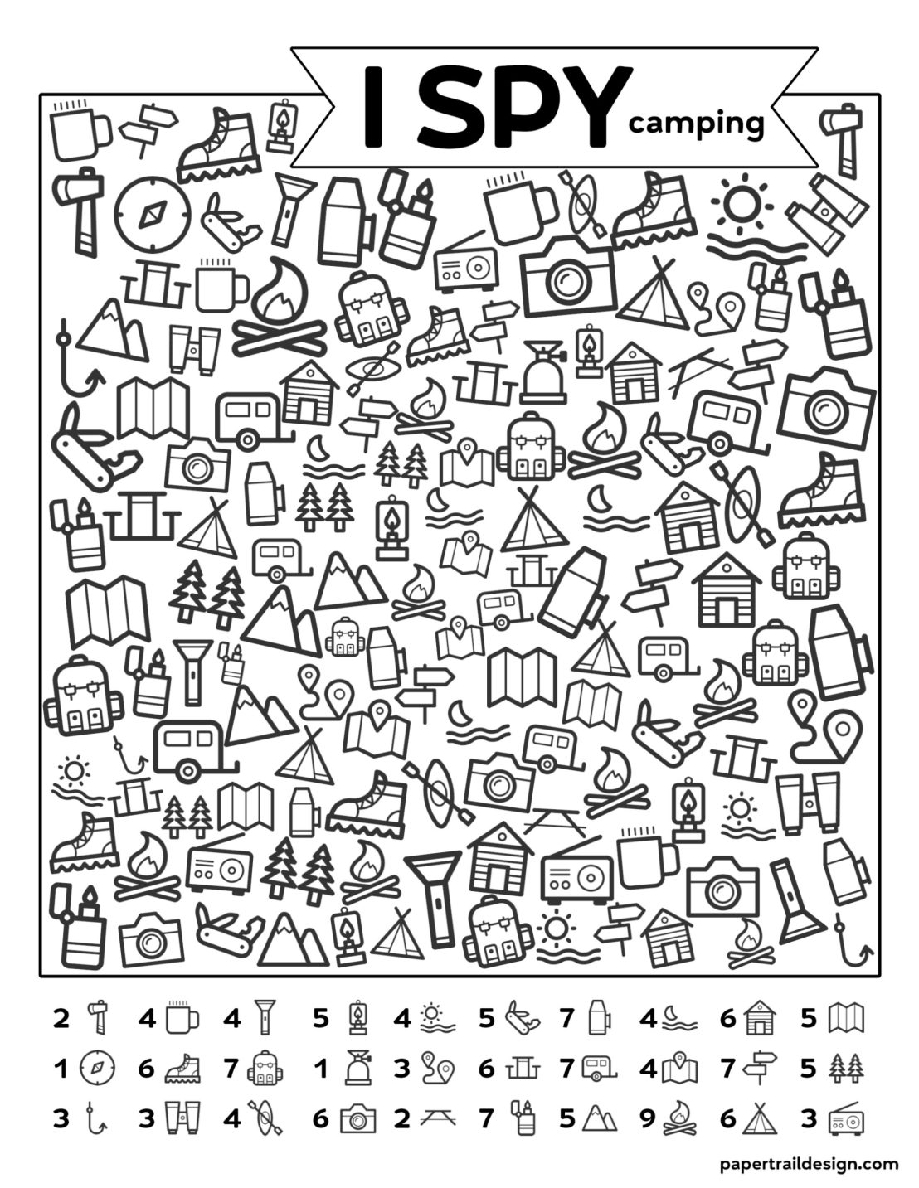

**Get to Know Me Better!:**



**The King of the Birds Folktale**

Once upon a time all the birds agreed to have a king, but no bird would agree to another bird being king, so they agreed for all the birds to start together and who ever flew highest would be the king.

When they were starting the wren hid among the eagle's feathers. The eagle flew up high above all the other birds and shouted out "I am the king of the birds", but while he was shouting the wren fluttered out of his feathers and flew up high above him then the wren shouted out, "I am the king of the birds. This is how the wren became king of the birds.

**Butterfly Meditation**

Close your eyes and take in a nice deep breath.

Let the sights and sounds of this room fade away as you focus on your breathing and get ready to visualize a fun and relaxing adventure. Your body begins to feel deeply relaxed and sinks down further where you are. Your arms and legs begin to feel very heavy. You patiently enjoy this time as your mind and body continue to relax.

Now, imagine you’re a beautiful butterfly fluttering high in the sky. Below you, there is a lovely green valley with lots of colourful flowers, just waiting for you to enjoy. You feel the wind gently blow against your delicate wings. As the wind touches you, it gently blows away any worries or any stress you feel. Your mind is clear and calm. You feel light as the wind itself - a cheerful butterfly gliding and fluttering anywhere you wish to go.

Did you know that as a butterfly moves from flower to flower, it spreads just what the other plants need to thrive and grow? You are like that, too. You can flutter about peacefully and beautifully - spreading kindness, happiness, and goodness wherever you go!

The sun touches your colourful body and warms you. The big, puffy clouds floating in the sky remind you how relaxed and calm you can be whenever you want, just by thinking about it.

It’s so nice to be this light and airy.

Your butterfly self has left any worries or fears behind.

You love how it feels to beat your wings and fly, and anytime you start to feel tired, you can land on a leaf or flower and rest. You spread your lovely wings in a huge stretch. You are completely peaceful and content as you allow your true happiness to shine through. It feels so good.

Your body is calm, and your mind is peaceful.

You can fly around as long as you’d like – exploring or just floating gently on the wind.

Take in a deep breath now and exhale slowly.

When you are ready, give your body another big stretch and slowly open your eyes.

What did you like best about being a butterfly? Keep that feeling with you if you can. And remember, you can always come back here - or to any calming place - just by using your mind.