December
Activity Pack 1

Dear Friends,

As we approach the close of the year, we extend warm wishes for a festive season filled with the comforts of home and the joy of good company.

As the New Year beckons, take solace in the returning light even before its official arrival. The Winter Solstice, marking the longest night, occurs on December 21st. By Christmas Day, the skies begin to brighten, welcoming the sun to linger a little longer—a poignant reminder that after every period of darkness, there comes light.
With heartfelt warmth, we wish you a Merry Christmas and a joyous commencement to the New Year.

Reflecting on the year gone by, we want to express our deep gratitude for your unwavering support. This year has seen significant milestones for ASI, including the opening of our 50th Day Care Centre, the establishment of the first dementia-specific shopping centre, and the creation of the first dementia-specific town. These achievements are a testament to the collective effort and dedication of our community.

As we express our gratitude, we also look forward to the promise of the coming year. May it bring you and your loved one’s health, happiness, and an abundance of cherished moments.
Remember, ASI is just a phone call away should you ever need us. Our helpline number is 1800 341 341, staffed by trained professionals ready to listen and support you.
May you thoroughly enjoy this December’s Activity Pack!

"What good is the warmth of summer, without the cold of winter to give it sweetness."
— John Steinbeck

Useful Resources:
Useful Resources:
1. Our Free Helpline and Dementia Nurse Support Line are available at: Phone: 1800 341 341 and Email: helpline@alzheimer.ie
2. The ASI now also has a new online Virtual Dementia Hub where you can go for a full range of activities – you can even listen to some wonderful poetry and songs especially. Just go to www.virtualdementiahub.ie
3. We are hosting a number of Virtual Cafes. They are a place to come together, share a cuppa and listen to our amazing guest speakers. For information on how to attend visit: https://alzheimer.ie/service/alzheimer-cafe/
4. The ASI also have a huge library of factsheets and resources available on: https://alzheimer.ie/get-support/resources-and-factsheets/
5. For musical videos and resources Music For Dementia are a wonderful resource: https://musicfordementia.org.uk/
6. The Irish Museum of Modern Art (IMMA) have a huge collection available to view online at: https://imma.ie/collection/
7. Emergency Response Numbers: 999 or 112 9. HSE 24/7 Your Mental Health Information Helpline: 1800 111 888

Table of Contents

Activity | Pages
Christmas Quiz | 6-7
Pictures to Colour | 8-11
Christmas Word Search | 12
How Many Words Can You Make From Merry Christmas? | 13
Christmas Traditions | 14
Riddle Me This | 15-16
Little Tree By E.E. Cummings | 17
White Christmas By Bing Crosby | 18
Spot the Difference | 19-20
Finish the Lyric | 21-22
Christmas Crossword | 23
Christmas Carol Charades | 24
A Treasure A Folktale Heard in Mayo | 26
When You Were Sweet Sixteen  By James Thornton (performed by The Fureys) | 27
Let’s Make Our Own Christmas Stocking | 28
Let’s Make Christmas Trees | 29
Guided Relaxation Visualizing a New Year | 30-31

Christmas Quiz – Questions:

1. Whose birthday is celebrated on Christmas Day?
[A] Jesus Christ
2. What colour of Christmas am I dreaming of?
[A] A white Christmas
3. Name three items contained in eggnog.
[A] Sugar, milk, eggs
4. What is the night before Christmas?
[A] Christmas Eve
5. In the song, how many days of Christmas are there?
[A] 12
6. What is the name of the day after Christmas?
[A] Boxing Day
7. What are you supposed to do when you find yourself under the mistletoe?
[A] Kiss
8. Which Christmas reindeer has a shiny nose?
[A] Rudolph
9. What is the main course for a traditional Christmas dinner?
[A] Turkey and stuffing
10. Who once stole Christmas?
[A] The Grinch
11. What snack is traditionally left out for Santa Claus?
[A] Cookies
12. What spirit is traditionally added to Christmas pudding?
[A] Brandy
13. What food is good luck to eat on each of the 12 days of Christmas?
[A] Mince Pies
14. Which two famous sporting events begin on Boxing Day?
[A] The Sydney to Hobart Yacht Race and test cricket at the Melbourne Cricket Ground
15. What Christmas decoration was originally made from strands of silver?
[A] Tinsel
16. Who sang “All I Want for Christmas is You”?
[A] Mariah Carey
17. In what country did the tradition of putting up Christmas trees originate?
[A] Germany
18. What do people traditionally put on top of a Christmas tree?
[A] An angel
19. Elvis isn’t going to have a white Christmas, he’s going to have a……..?
[A] Blue Christmas
20. What popular Christmas song was actually written for Thanksgiving?
[A] Jingle Bells

Pictures to Colour

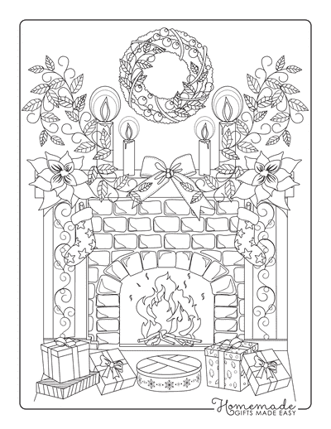

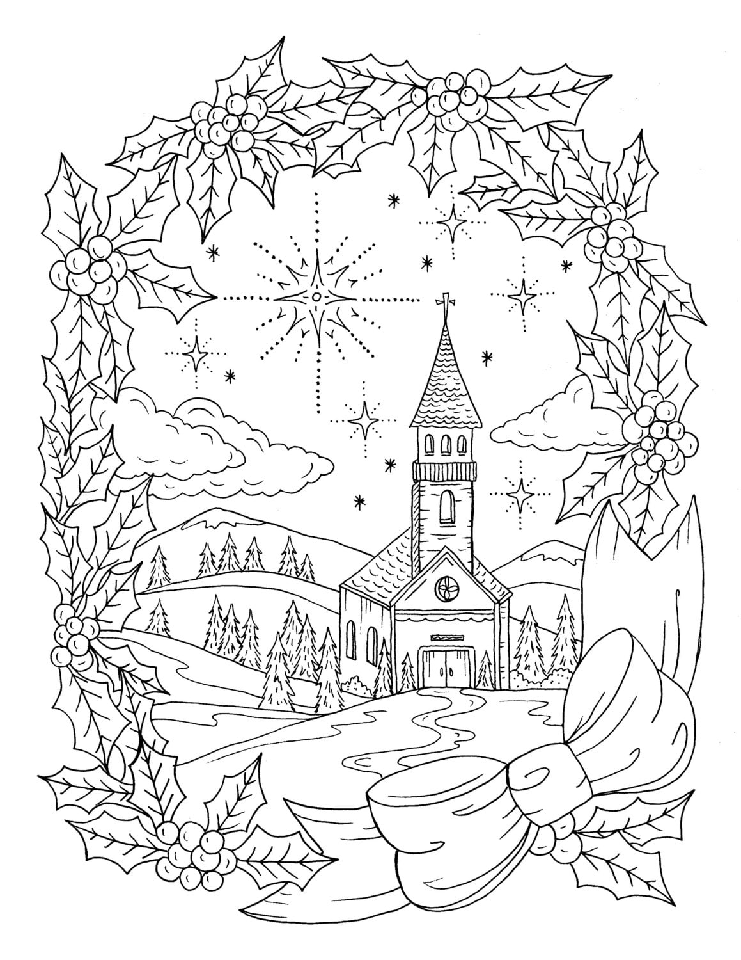

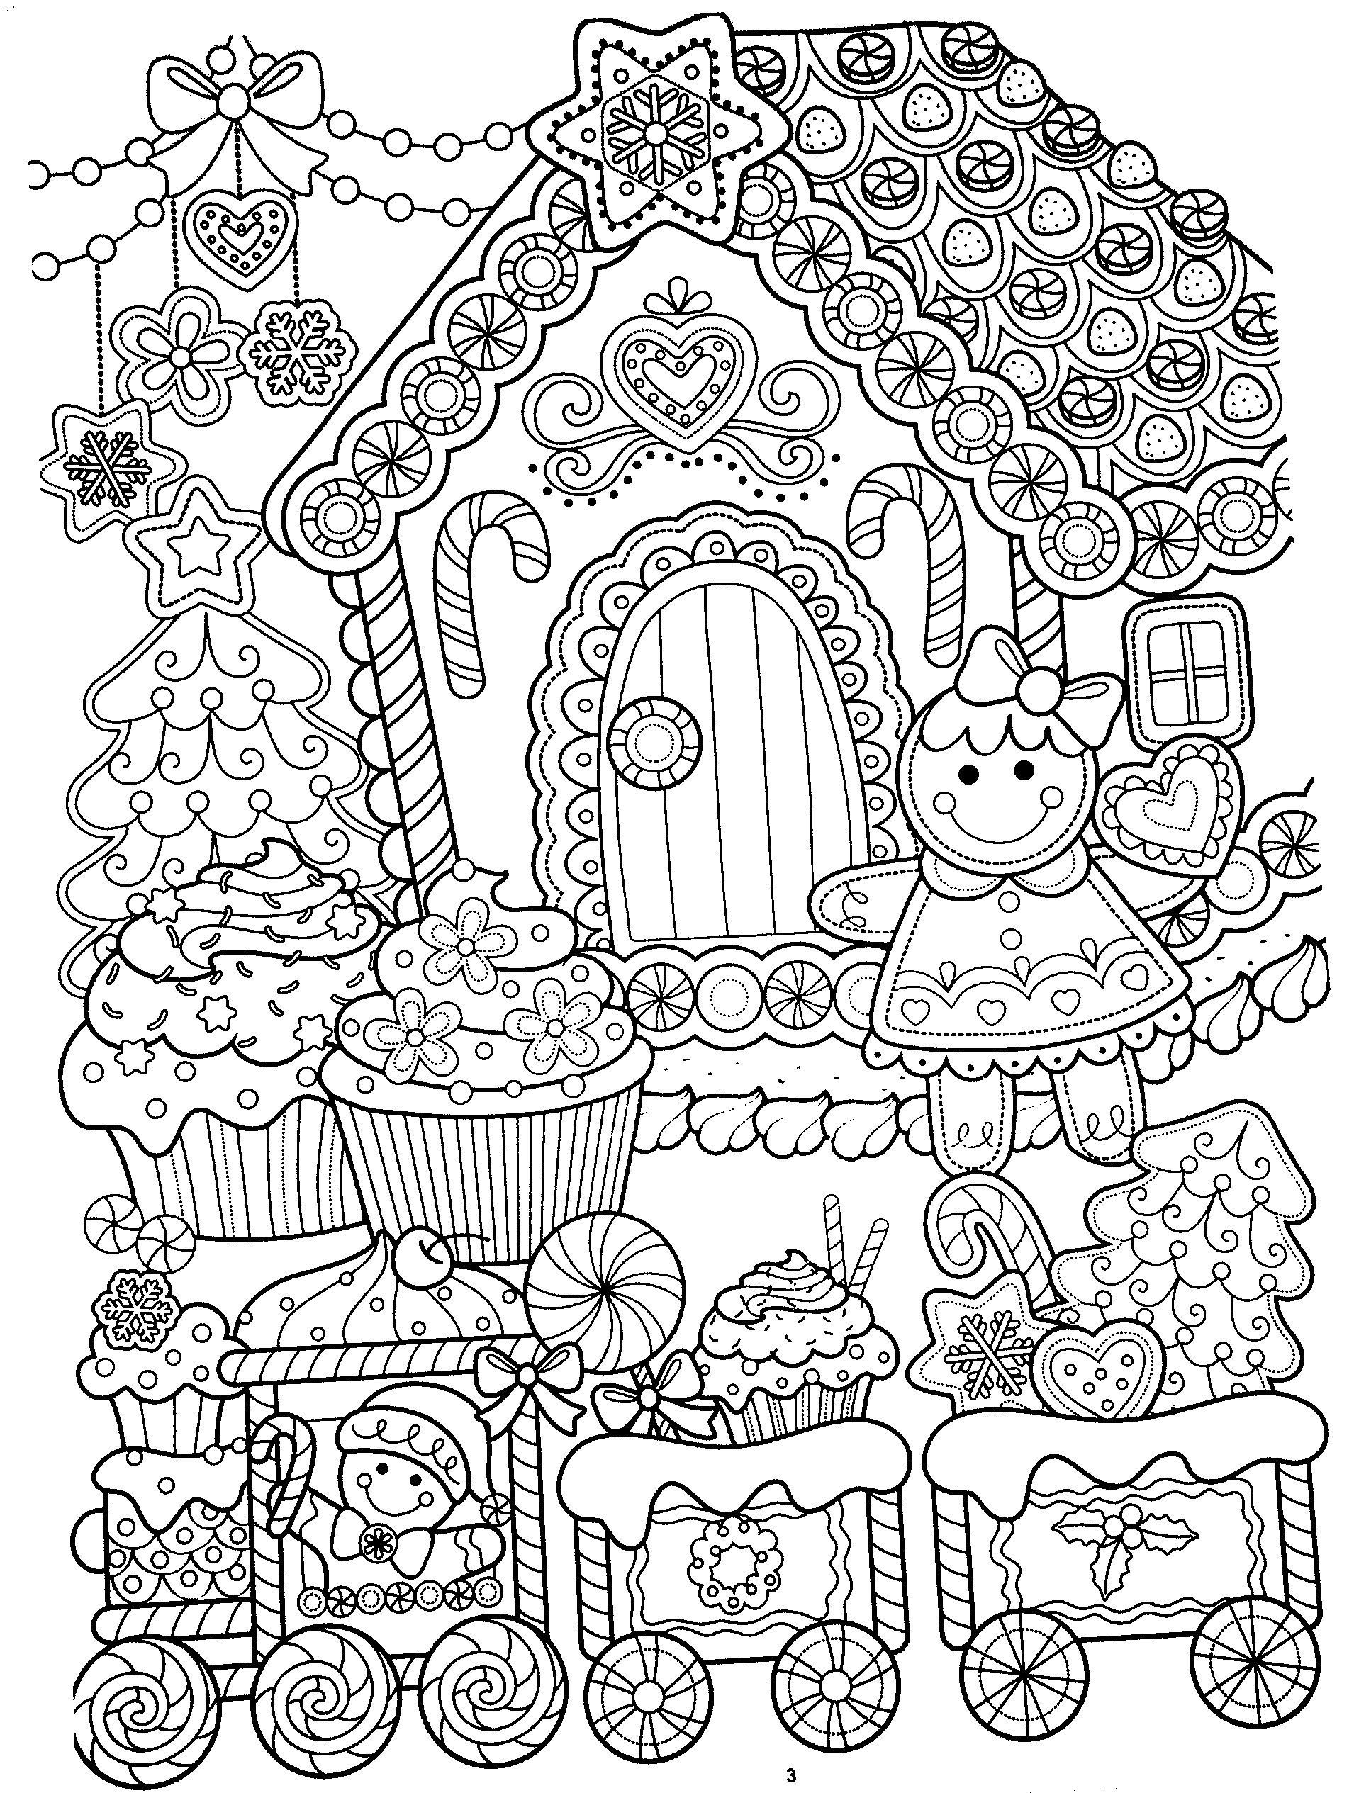

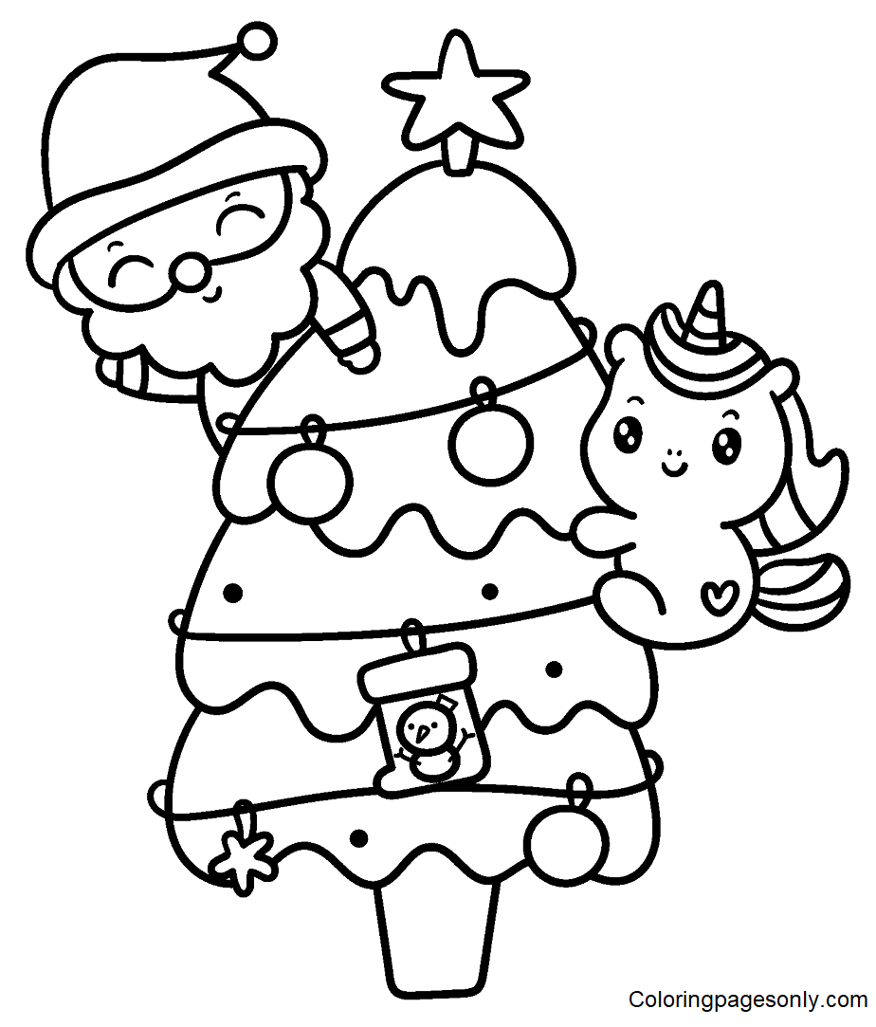

Christmas Word Search

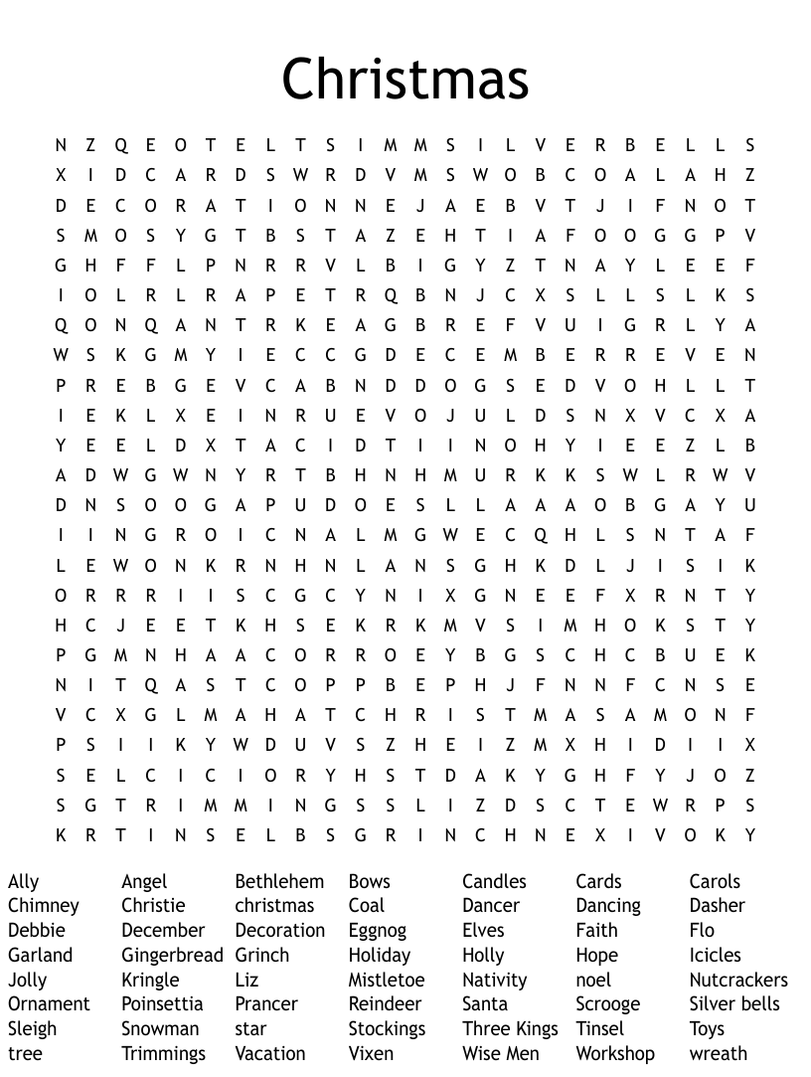

How Many Words Can You Make From ‘Merry Christmas’
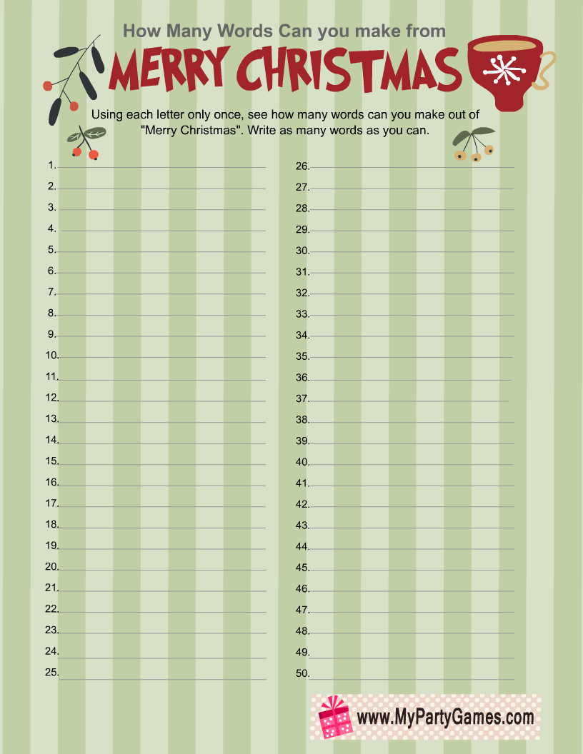

Christmas Traditions
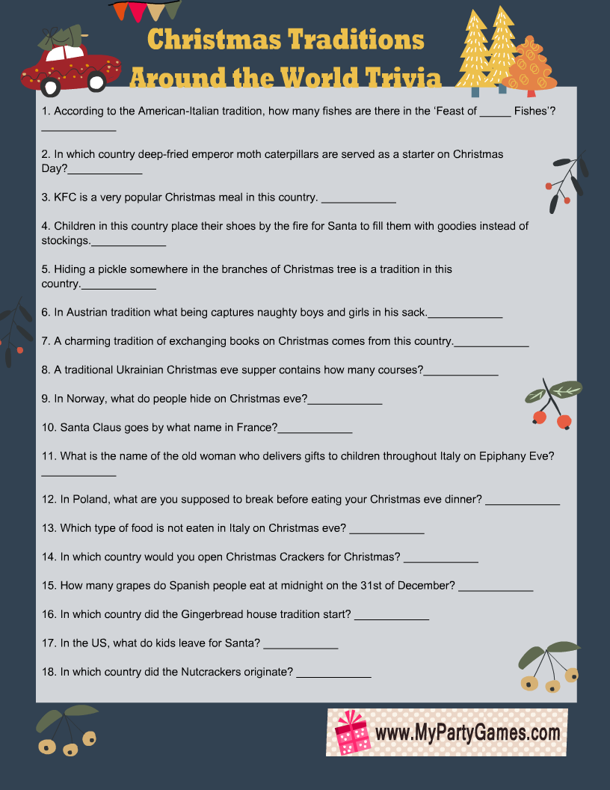

Riddle Me This!

- What two things can you never eat for breakfast?
Lunch and Dinner.

- What has a face and two hands but no arms or legs?
A Clock.

- What tastes better than it smells?
A Tongue.

- What kind of room has no doors or windows?
A Mushroom.

- What goes up and never comes down?
Your Age.

- What word becomes shorter when you add two letters to it?
Short.

- Two children are born on the same day from the same mother but they are not twins. How is that possible?
They are two out of three triplets!

- Johnny's mother had three children. The first child was named April. The second child was named May. What was the third child's name?
Johnny!

“Little Tree”
by e.e. cummings
little tree
little silent Christmas tree
you are so little
you are more like a flower
who found you in the green forest
and were you very sorry to come away?
see I will comfort you
because you smell so sweetly
i will kiss your cool bark
and hug you safe and tight
just as your mother would,
only don't be afraid
look the spangles
that sleep all the year in a dark box
dreaming of being taken out and allowed to shine,
the balls the chains red and gold the fluffy threads,
put up your little arms
and I’ll give them all to you to hold
every finger shall have its ring
and there won't be a single place dark or unhappy…

White Christmas
By Bing Crosby

I'm dreaming of a white Christmas,
Just like the ones I used to know.
Where the tree-tops glisten,
And children listen
To hear sleighbells in the snow.
I'm dreaming of a white Christmas,
With every Christmas card I write,
"May your days be merry and bright,
And may all your Christmases be white".
I'm dreaming of a white Christmas,
Just like the ones I used to know.
Where the tree-tops glisten,
And children listen
To hear sleighbells in the snow.
I'm dreaming of a white Christmas,
With every Christmas card I write,
"May your days be merry and bright,
And may all your Christmases be white".

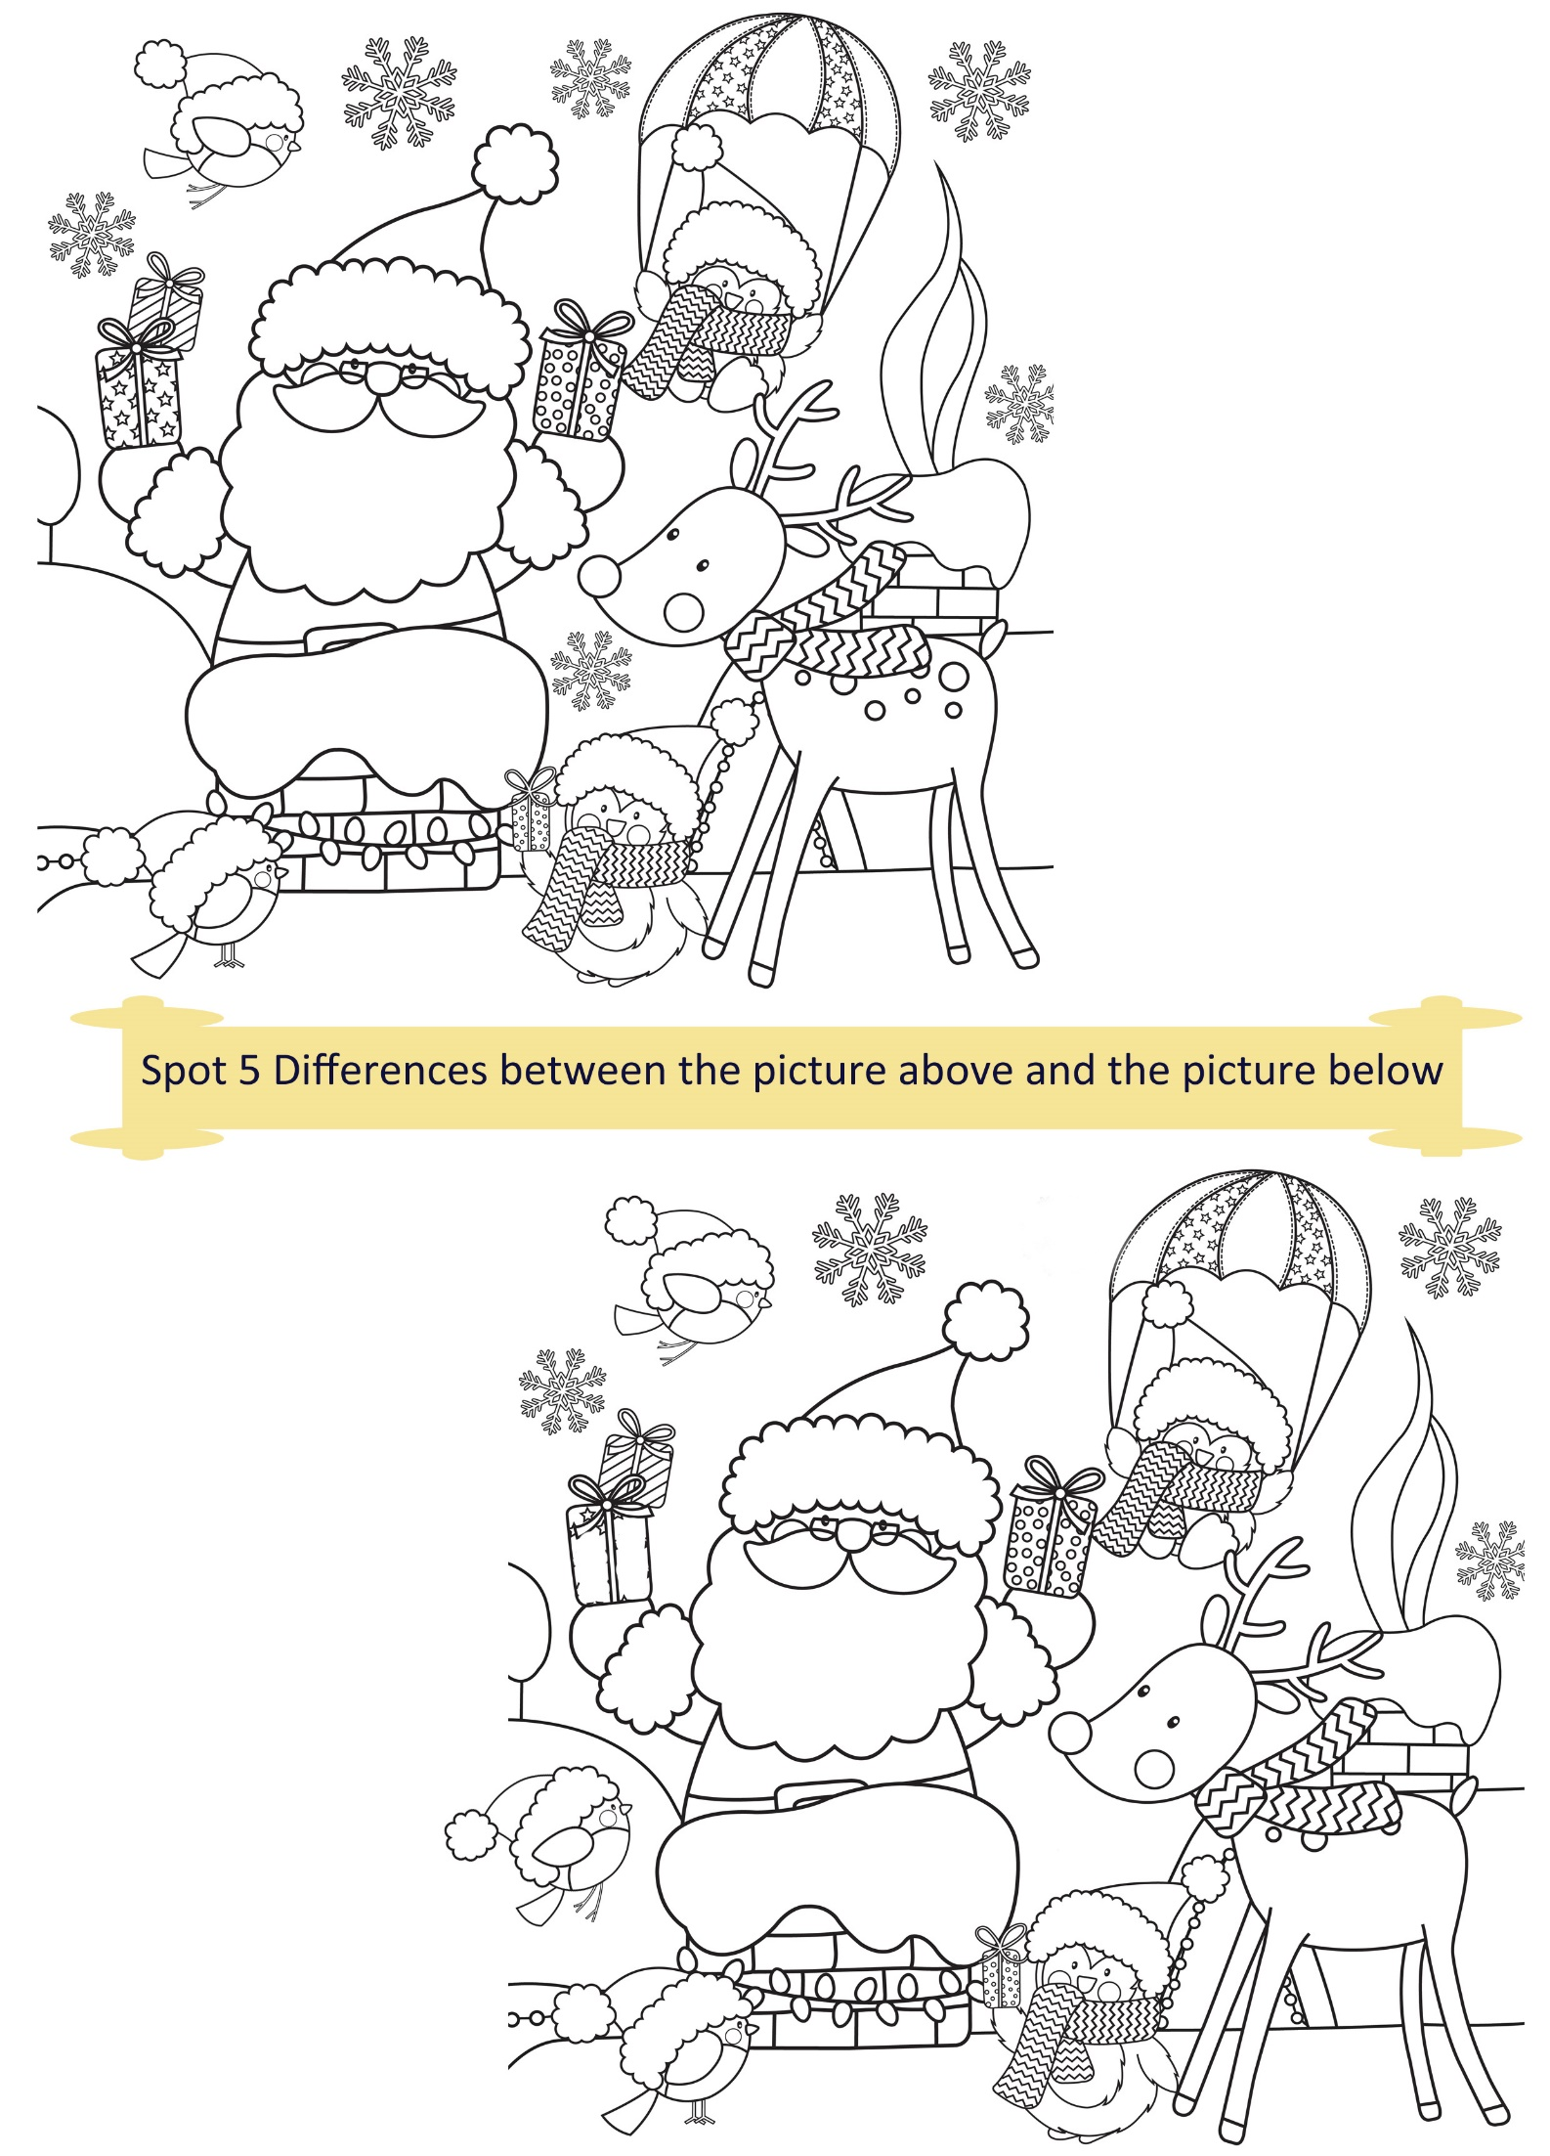
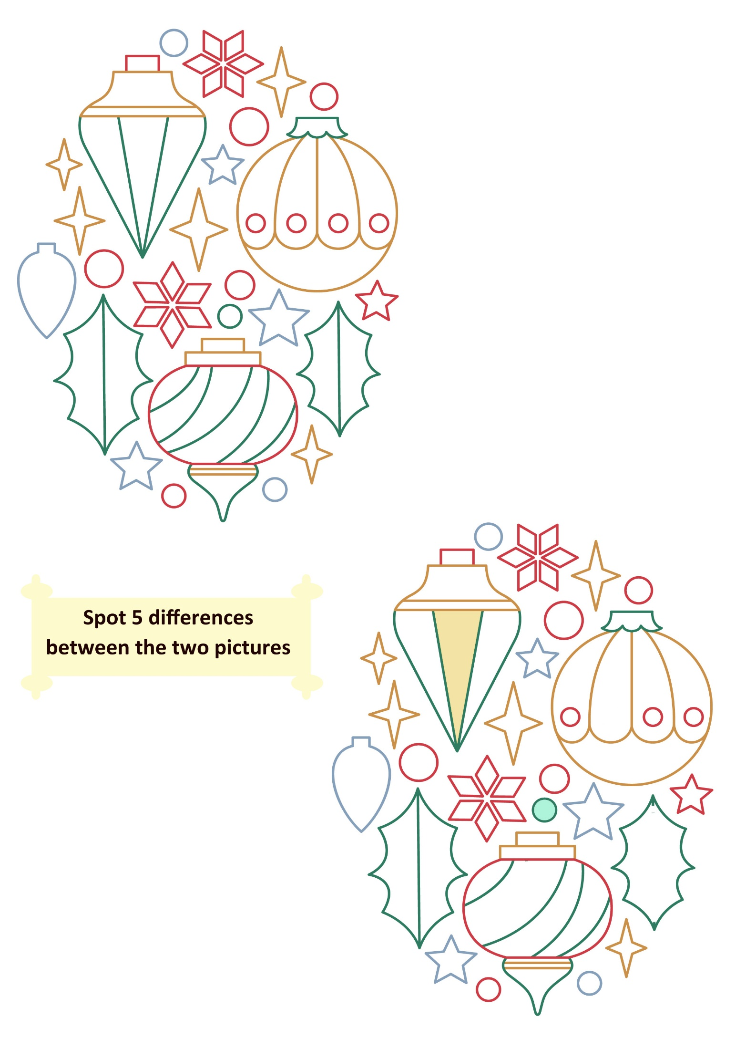
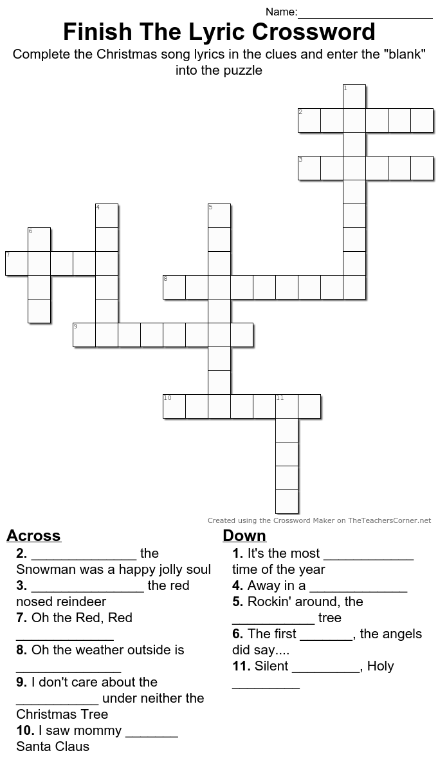21
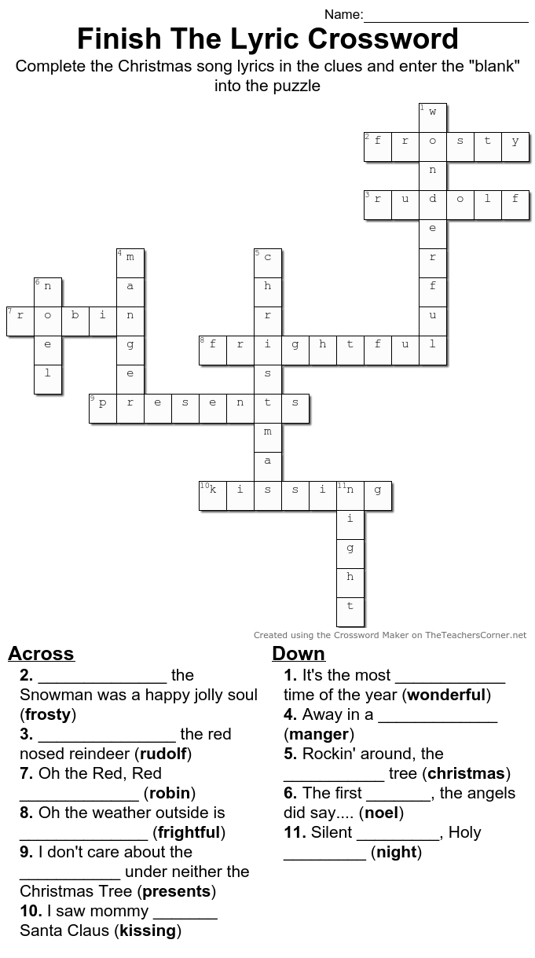22
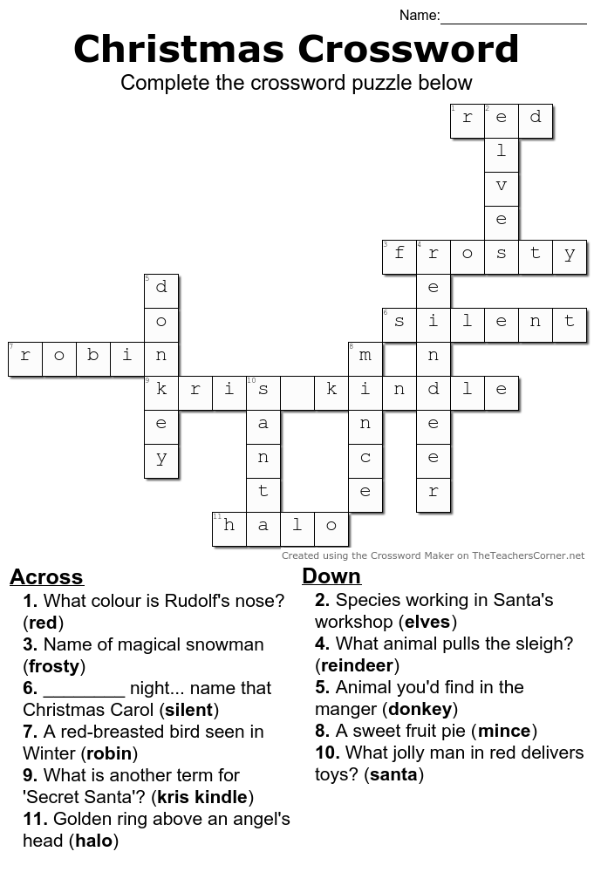

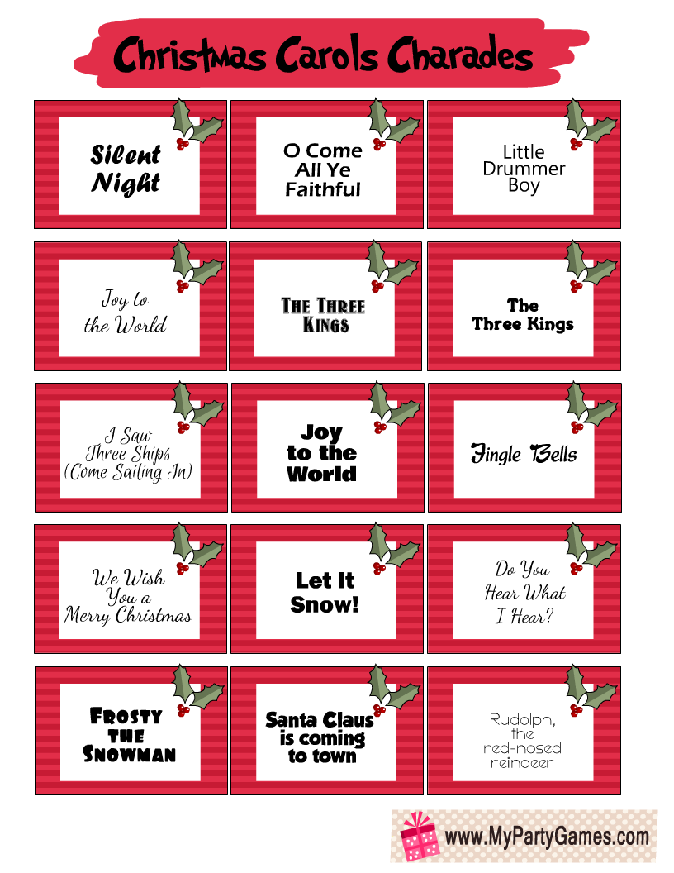

A Treasure (A Folktale heard in Mayo)

Once upon a time there was a man and his wife and they had nothing to eat. They left home to seek their fortune. The man told his wife to pull the door after her. Misunderstanding him, she pulled it after her on the road and when he noticed they had travelled too far to return.

When night came on they were passing through a wood. They went up on a tree and brought the door with them resting for the night. During the night there came a band of robbers and bags of gold with them. Where did they camp, but right under the tree where the old pair were resting! After a while the woman got tired holding the door and at last she let it go. It made a terrible noise going down. When the robbers heard the noise up over them they thought it was a sleeping bear falling on top of them and that they’d be caught and killed for sure!

They went off in a hurry and left all the bags of money after them. As soon as the robbers were gone the man and his wife came down from the tree and got all the money. They brought it home and lived happy ever after – they even bought a new door!

When You Were Sweet Sixteen
By James Thornton (performed by The Fureys)

When first I saw the love light in your eye
I dreamt the world held naught but joy for me
And even though we drifted far apart
I never dream, but what I dream of thee

I love you as I never loved before
Since first I met you on the village green
Come to me or my dream of love is o'er
I love you as I loved you
When you were sweet
When you were sweet sixteen

Last night I dreamt I held your hand in mine
And once again you were my happy bride
I kissed you as I did in Auld Lang Syne
As to the church we wandered side by side

I love you as I never loved before
Since first I met you on the village green
Come to me or my dream of love is o'er
I love you as I loved you
When you were sweet
When you were sweet sixteen

Let’s Make Our Own Christmas Stocking!

Let’s Make Christmas Trees!

Materials:
- Wine cork
- Pinecones
- Glitter gold paper
- Green Paint (we used acrylic paint)
- Small Pom Poms or any decorations
- Hot glue gun
- Fine white glitter (optional)

Instructions
Step 1. Hot glue the wine cork to your pinecone.
Step 2. Paint the pinecone green.
Step 3. Sprinkle with fine white glitter (optional)
Step 4. Hot glue your tiny pom poms.
Step 5. Cut out a small star from your glitter paper and glue to the top of your pinecone tree.
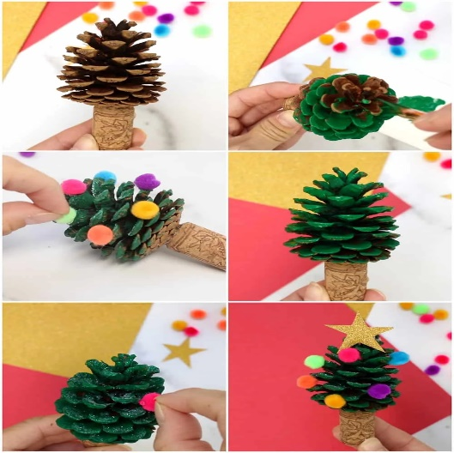

Guided Relaxation: Visualizing the New Year

Just imagine you’re lying somewhere very comfortable, and your body starts to relax more and more. You begin to feel warm and cozy inside even though the outside air has grown crisp. The trees have lost their leaves and have gone to sleep for the winter.

Imagine yourself curled up in front of a nice warm fireplace. You watch as the flames flicker yellow and red. The golden yellow flame seems to relax you even further as you enjoy its warmth. As you lie here enjoying this moment of relaxation, you start to remember some wonderful things that have happened this past year.

There have been many moments that have made you happy; many moments that have made you smile and grateful.

It’s been a good year.

You’ve grown on the outside and on the inside too. You’re smarter and wiser this year. You know yourself better, and you’re getting to know your personal gifts more and more.

The new year will bring a brand new start.

Now is the time to think about all the amazing things you want to accomplish. Remember, you can achieve anything you put your mind to!
So start to imagine all the wonderful things you’d like to do this coming year. Maybe you want to get better at something you enjoy doing, or perhaps learn a new skill. Maybe you want to spend more time on yourself.

Whatever you decide to do this coming year will be a wonderful goal to work towards each and every day.

Always remember to have faith in yourself and in your ability to accomplish your dreams. By using your heart and your mind together, you can create a fantastic year filled with joy, happiness, and fun!

Now take in a deep breath and imagine yourself at the end of the year having accomplished all these wonderful things you’ve been thinking about. Doesn’t it feel wonderful?

Picture yourself as having succeeded, and hold on tightly to that image in your mind and heart!

Now allow peacefulness and happiness to fill up your entire body, going into each and every cell.

When you’re ready you can open your eyes and give your body a big stretch… and be ready to live your dream!

